This is a technical assignment for the scope of senior backend engineer

Overview
The task is to write a simple django / fast-api microservice for an HR company . You would be responsible for building the API that populates the employee search directory .
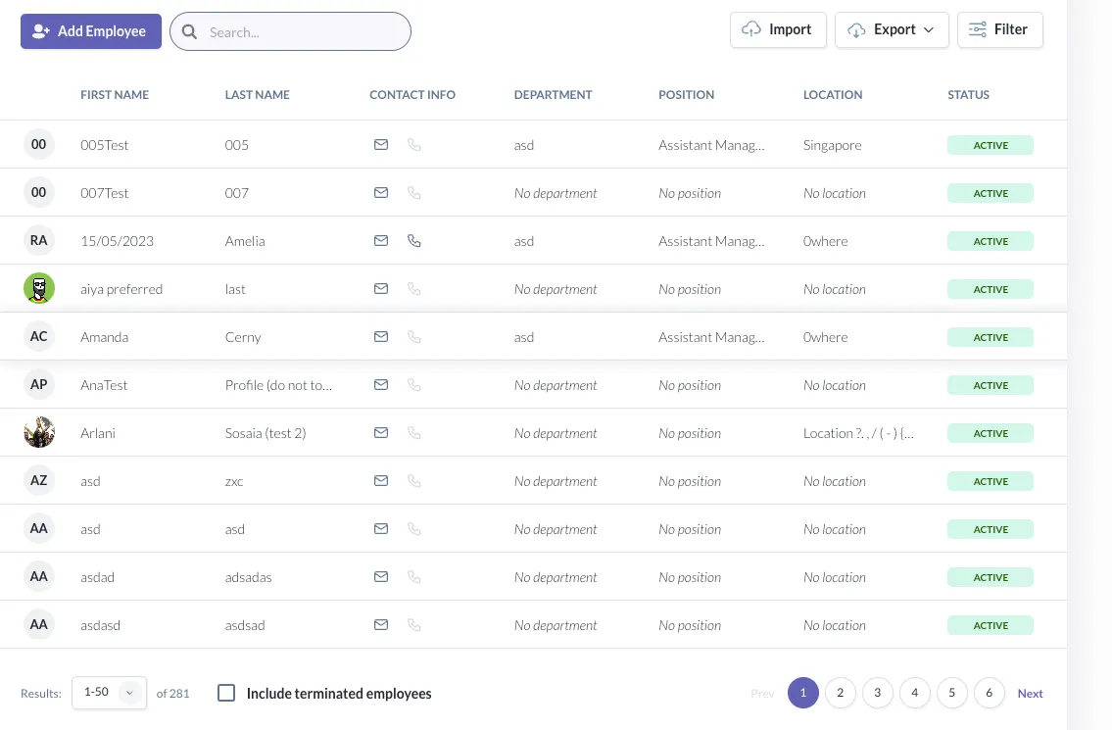
Feel free to create entities and their attributes as you like in the relational DB .
💡 Only the search API has to be implemented . Please ignore the Add employee Import Export CTA
💡 You are only required to implement the search API . You do not have to implement crud API for any of the entities
The following are the filter options of the API .
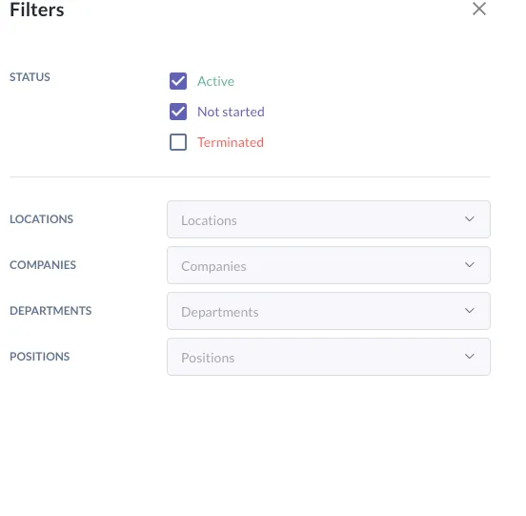

Dynamic columns :
Different organisations will love to have different columns in the output , while the above example displays contact info department location position . Some organizations would love to display the department location position columns only . So you can assume the order , the columns are configurable at an organization level .
💡 you do not have to create crud api to store the configuration of columns for the organizations . Assume it’s stored in configuration of your choice ( DB / file / etc )

Performance :
Please assume that there are millions of users in the database , so do design the API considering the heavy load that could be placed on the API ( after sharding etc )

Rate-limiting
We do not want users abusing the API , so please create an appropriate rate-limiting system as possible to prevent the user from spamming the API

Deliverables
The following are things to include in your submission:
- Link to your Github repository containing all code and toolings needed to install and run your CLI tool
- A README.md file containing anything you think is important to know for a potential end-user (likely a fellow developer). Assume use of a unix environment (mac/linux)
The following are functional requirements
- The service must be containerized .
- The API information must be sharable in an OPEN API format
- The API must be unit tested
- No external library is allowed for rate-limitting. Please your own implementation no matter how naive it is .
- There shouldn’t be a data leak in the API such ( information of other organisation’s users , extra attributes of user that are not displayed on the UI etc ) .
- The assignment must be in python / fast API
💡 there is no need to create the relations in migration etc . Please stick to focusing as much time on the API as possible
The following are the non-functional requirements:
- You may not use any external dependencies or libraries (only standard library is allowed)
- You may use external testing libraries if you choose to write tests
- The application should execute correctly in a Linux (or UNIX-like) environment

Final notes
If we find your submission of sufficient quality, we will have a further discussion on your code architecture as well as pair to modify your code to simulate a real-world situation where stakeholders will require constant change/feature upgrades. So don't copy and paste too much.

